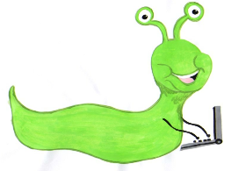

Lyng Primary School Knowledge Organiser

Online Safety



Self Image and identity

Year 6

|  |  |
| --- | --- |
| What Goldilocks and Step On words will I use? | |
| Identity | Who you are |
| Evaluate | Form an idea about something |
| Representation | How someone or something is show. Speaking on behalf of others. |
| Stereotype | A set idea that people have about what someone or something is like |
| Inclusivity | Providing everyone with an equal access to opportunities |



**Aims of this unit**

I can identify and critically evaluate online content relating to gender, race, religion, disability, culture and other groups and explain why it is important to challenge and reject inappropriate representations online.

I can describe issues online that could make anyone feel sad, worried, uncomfortable or frightened.

I know and can give examples of how to get help online and offline. I can explain the importance of asking until I get the help needed.

* Lesson 1 – Challenging stereotypes
* Lesson 2 – Managing online situations
* Lesson 3 – Giving online safety advice

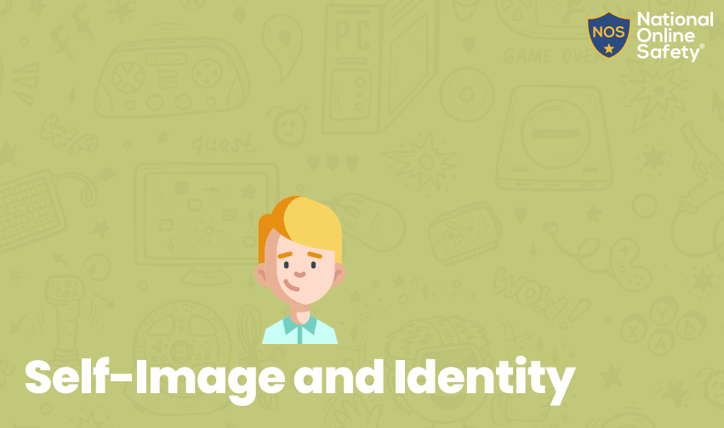

**In this unit…**

Children will learn to assess information they see online based on the protected characteristics and learn why they are important and how to make their own decisions on matters they see online. They will learn to be empathetic towards things seen online and know how to get advice if needed and who trusted adults are.